Radiation Survey Analysis

Here is the radiation survey analysis. We can see interesting aspects related to the different values that were collected. I managed to showcase all the values as a whole and stratified by the lead versus rampart. I did notice a large outlier in the participant radiation values (Case 4_005 = 372.9) that I removed from the graph.

* 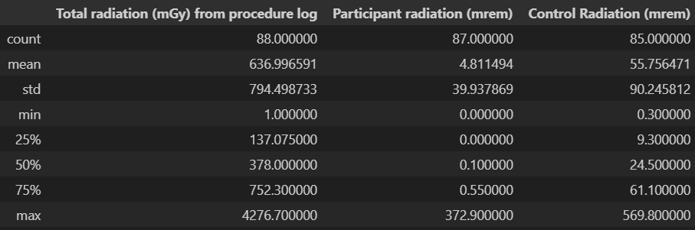
* Radiation Box Plots
  + 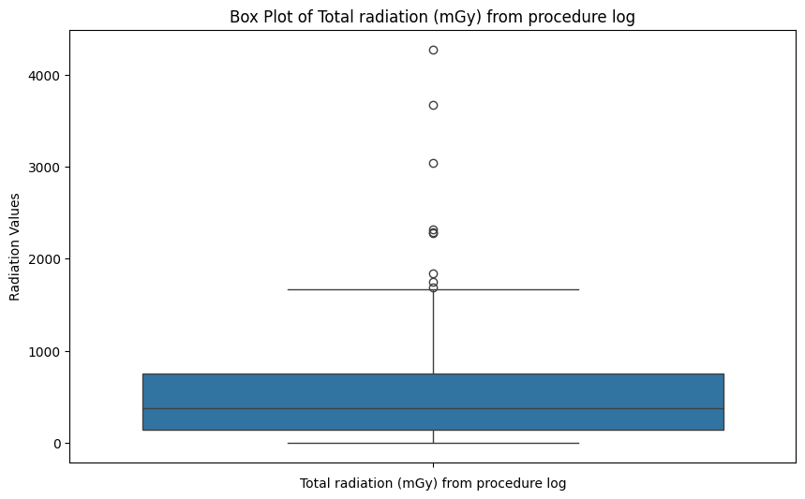
  + 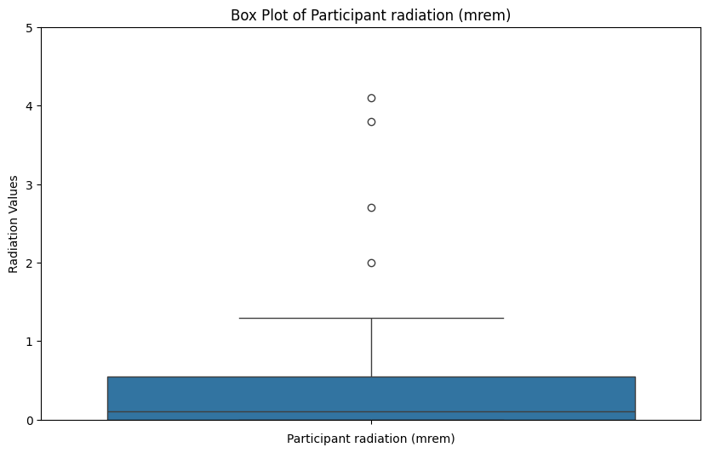
  + 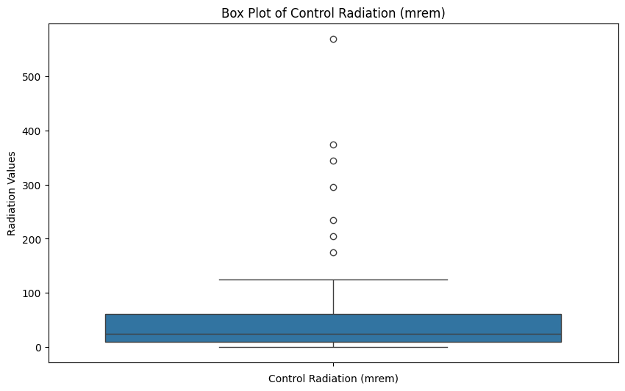
* Correlation of the radiation data:
  + 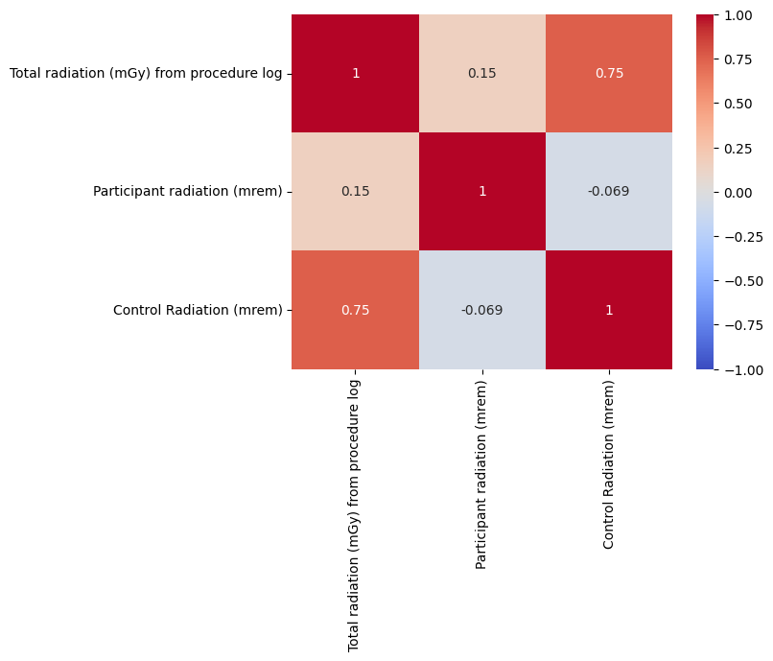
* Radiation Rampart versus Lead
  + 
   